

**T.C DOĞUŞ UNIVERSITY**

**FACULTY OF ENGINEERING COMPUTER ENGINEERING**

**Internship Management Project**

**Come 491 Project**

**Prepared by**

**Taner Ileri**  **20190301015**

**Ayça Sena Akın 20190301060**

**Bahadır Öztürk 20190301029**

**Koray Kocaelli 20190301055**

**MuhammedTalha Sakaoğlu 20190301057**

**Thesis Advisor**

**Asist. Prof. Dr. M Zahid Gürbüz**

**Istanbul, February 2024**



# PREFACE

We would like to thank, Assit. Dr. M.Zahid Gürbüz who has with us many phase of the project.

İstanbul, Febuary 2024 AYÇA SENA AKIN

BAHADIR ÖZTÜRK

KORAY KOCAELLİ

MUHAMMEDTALHA SAKAOĞLU

TANER İLERİ

# SUMMARY

Despite the continuous progress of technology, humanity constantly strives to keep up with these developments. However, the rapid pace of technological evolution often renders traditional systems outdated, adding challenges to this effort. Our initiative, acknowledging the need for adaptation, has undertaken a digital transformation project by migrating the manually conducted internship tracking process to a digital environment. Focused on creating a revolutionary internship tracking system for university students, this comprehensive project centers around the development of a web application. The existing system often requires students to engage in a cumbersome process involving numerous emails and waiting for school responses. In contrast, our web application establishes a dynamic and mutual relationship between students and advisors. This platform facilitates a smooth workflow by allowing students easy access to essential documents and the ability to upload necessary information. Advisors can efficiently review applications and provide timely approvals, transforming the internship management process into a more responsive and interactive experience for both parties. Additionally, advisors can monitor the status of all students and make necessary corrections. While there may be instances where mutual email communication is necessary, the overall perspective of the web application minimizes this need.

Keywords: Internship Tracking System, Digital Transformation, Web Application.

# ÖZET

Teknolojinin sürekli ilerlemesine karşılık insanoğlu sürekli olarak bu gelişmelere ayak uydurmaya çalışmaktadır. Ancak teknolojik evrimin hızlı temposu geleneksel sistemleri sıklıkla modası geçmiş bıraktığından, bu çabanın da zorlukları var. Uyarlama ihtiyacını kabul eden girişimimiz, manuel yürütülen staj takip sürecini dijital ortama taşıyarak dijital dönüşüm projesi gerçekleştirmiştir. Üniversite öğrencilerine yönelik bu devrim niteliğindeki staj takip sistemi, kapsamlı bir web uygulamasının oluşturulmasına odaklanıyor. Mevcut sistem çoğu zaman öğrencilerin çok sayıda e-posta gönderme ve okul yanıtlarını bekleme gibi zahmetli bir sürece girmelerini gerektirmektedir. Buna karşılık web uygulamamız, öğrenciler ve danışmanlar arasında dinamik ve karşılıklı bir ilişki kurar. Bu platform, öğrencilerin temel belgelere kolayca erişmesine ve gerekli bilgileri yüklemesine olanak tanıyarak akıcı bir iş akışı oluşturur. Danışmanlar da başvuruları verimli bir şekilde inceleyebilir ve zamanında izinler sağlayabilir, böylece staj yönetimi sürecini her iki taraf için de daha duyarlı ve etkileşimli bir deneyime dönüştürebilir. Ayrıca, danışmanlar tüm öğrencilerinin durumunu kontrol edebilir ve onlara düzeltmeler yapabilir. Bazı durumlarda, sonunda karşılıklı e-posta göndermek gerekebilir, ancak genel perspektifte web uygulaması bu konuda bunu minimum düzeyde tutar.

Anahtar Kelimeler: Staj Takip Sistemi, Dijital Dönüşüm, Web Uygulaması.

**SYMBOLS**

**ABBREVIATIONS**

VS Visual Studio

IMS Inteship Management System

CQRS Command Query Responsibility Segregation

API  Application Programming Interface

IIS Internet Information Service

# CONTENTS

PREFACE i

SUMMARY i

ÖZET ii

SYMBOLS iii

ABBREVIATIONS iv

CONTENTS v

LIST OF FIGURES vii

LIST OF TABLES vii

REQUIREMENTS ANALYSIS DOCUMENT 1

1. INTRODUCTION 1

1.1. Purpose of the system 1

1.2. Scope of the system 1

1.3. Objectives and success criteria of the project 1

1.4. Definitions, acronyms, and abbreviations 2

1.5. References 2

1.6. Overview 2

2. CURRENT SYSTEM 2

3. PROPOSED SYSTEM 3

3.1. Overview 3

3.2. Functional requirements 3

3.3. Nonfunctional requirements 3

3.3.1. Usability 4

3.3.2. Reliability 4

3.3.3. Performance 4

3.3.4. Supportability 4

3.3.5. Implementation 4

3.3.6. Interface 4

3.3.7. Packaging 5

3.3.8. Legal 5

3.4. System models 5

3.4.1. Scenarios 5

3.4.2. Use case model 7

3.4.3. Object model 8

3.4.4. Dynamic model 10

3.4.5. Database model — ER diagram 11

3.4.6. User interface—navigational paths and screen mock-ups 12

4. GLOSSARY 18

PROJECT BUDGET AND TIME PLAN 19

5. INTRODUCTION 19

5.1. Gantt Chart 19

5.1. Project Budget 19

5.2. Project Phase Distribution 20

5.3. Other Tables 20

PROJECT SPECIFIC CONTENT 21

6. INTRODUCTION 21

6.1. ACCESSIBILITY 21

6.2. USER MANUAL 21

6.3. TEST PLAN 21

6.4. MAINTENANCE PLAN 22

CONCLUSION AND DISCUSSION 23

REFERENCES 24

APPENDIX 25

BIOGRAPHY 27

**LIST OF FIGURES**

Figure 1 Use Case Model…………………………………………………………………...7

Figure 2 Objecet Model……………………………………………………………………...8

Figure3 Dynamic Model……………………………………………………………………..10

Figure 4 Database Model – ER diagram……………………………………………………..11

Figure 6 Home Page…………………………………………………………………………12

Figure 7 Internship Directive………………………………………………………………...12

Figure 8 Internship Notebook………………………………………………………………..13

Figure 9 Internship Forms…………………………………………………………………...13

Figure 10 Employment Certificate…………………………………………………………..14

Figure 11 Student and Advisor Login Screen……………………………………………….14

Figure 12 Student Info……………………………………………………………………….15

Figure 13 Internship Information Form (excel form)………………………………………..15

Figure 14 Intrership Approval……………………………………………………………….16

Figure 15 Internship Notebook……………………………………………………………....17

Figure 16 Gantt Chart……………………………….........………………………………….19

**LIST OF TABLES**

Table 1 Project Budget Table ……………………………………………………………….19

Table 2 Project Phase Distribution…………………………………………………………..20

Table 3 Other Tables - Meeting Information………………………………………………..20

**REQUIREMENTS ANALYSIS DOCUMENT**

**1 INTRODUCTION**

* 1. - **Purpose of the System**

Today, in an age where technology is rapidly evolving, educational processes must also keep up with this change. Students' internship processes play a critical role in their professional development. At this point, traditional internship book management and evaluation processes can be made more effective and efficient by supporting digitalization and technological innovations. We are planning that teacher can check the and keep it management and students can get forms and upload their internship documents.

**1.2** - **Scope of the System**

Students who want to apply for internship must follow the criteria determined by the universities. It must fill out the relevant internship application documents in accordance with the date ranges and internship regulations. Students whose application documents were approved as a result can start their internship programs officially. During the internship program, students should prepare their daily internship notebooks and submit them to the department that they are affiliated with at the end of the internship. They must submit the notebook they have completed. With the "Internship Management System" project developed within the scope of this study. This internship process carried out between has been combined under the roof of a web project and it is ensured that the transactions are carried out through this system. Accelerating, simplifying and facilitating the monitoring and management of the process is targeted.

**1.3** - **Objectives and Success Criteria of the Project**

Our main goal is to enable users within the system to perform their tasks easily and to ensure the flawless completion of operational practices in the system. For internship candidates, this involves being able to complete all necessary processes within the system, from the internship application process to the submission of documents, while simultaneously allowing their advisors to fulfill their responsibilities and duties towards the intern.

The project aims to facilitate the managing, addition, and control of essential documents in a structured manner, ensuring smooth operation without interruptions. The system should be capable of pausing operations when necessary and facilitating communication between the intern and the advisor. The communication should be reliable, traceable, transparent in its stages, and simple. These criteria are key success factors for this project.

**1.4** - **Definitions, Acronyms, and Abbreviations**

Internship Management System (IMS): The web-based platform developed for managing internship processes efficiently.

UML: Unified Modeling Language.

ISBN: International Standard Book Number.

**1.5** - **References**

Applying UML and Patterns, 3rd Ed., Craig Larman, Prentice-Hall, 2007

UML Distilled, 3rd Edition, Martin Fowler, Addison-Wesley, 2003

Head First Object Oriented Analysis and Design, Brett D. McLaughlin, Gary Pollice, Dave West, O'Reilly Media, 2006, ISBN: 059600867

Head First Design Patterns, by Eric Freeman, Elisabeth Robson and Bert Bates 2004, O'Reilly Media, ISBN: 0596007124

Software Engineering: Theory and Practice, 4th Ed., Pfleeger & Atlee, Prentice Hall, 2009

Thinking in C++, Bruce Eckel

**1.6** - **Overview**

This section will provide a brief summary of the document, highlighting key points such as the purpose, scope, objectives, and success criteria of the project.

**2 CURRENT SYSTEM**

In the past, the process of submitting internship notebooks required physical delivery, scanning, and subsequent emailing. This system led to complications and resulted in professors spending valuable time reviewing incomplete submissions. Each student had to be individually contacted for missing materials. To address these issues, we have implemented a new system to streamline the process and enhance efficiency. We have developed a dedicated website where both students and teachers can conveniently upload and access internship notebooks. This platform eliminates the need for manual handling and provides a user-friendly interface for swift and complete notebook submissions. This innovative approach not only saves valuable time for both students and professors but also ensures a more organized and accessible system for monitoring and managing internship notebooks. We believe that this improvement will greatly enhance the overall experience for all parties involved.

**3 PROPOSED SYSTEM**

**3.1 - Overview**

On our newly established website, distinct login credentials will be provided for students and teachers. Within the student portal, students will discover comprehensive guidelines detailing the content requirements for their internship notebooks. Additionally, an information system will be available, offering step-by-step instructions on the proper procedure for uploading internship notebooks. This dedicated space allows students to effortlessly submit their internship materials.

Teachers, with their separate login credentials, will gain access to a centralized platform where they can efficiently review and provide prompt feedback on students' notebooks. This enhanced control and visibility enable a more streamlined feedback process, ultimately fostering a more efficient and organized system for both students and teachers.

**3.2 - Functional Requirements**

Accessing Information and Documents:

Users will have the capability to access essential information and documents related to internship documentation. Relevant Information about Internship Procedures: Users will gain access to pertinent details concerning internship procedures and dates.

Document Upload Functionality: Users can upload the necessary documents to the system within designated timeframes.

Document Visibility: Both advisors and interns will be able to view documents uploaded to the system. Document Management

Functions: Users can perform actions such as editing, approving, or rejecting documents. Missing

Document Requests: The system allows the generation of requests for missing documents. Facilitated

Communication: The platform facilitates effective communication between interns and advisors.

Advisors' Activity Managing: Advisors will have the ability to manage and monitor activities through their individual dashboards.

**3.3 - Nonfunctional Requirements**

**3.3.1 - Usability:**

User Interface: The system should have an intuitive, visually appealing and user-friendly user interface.

Accessibility: Training: Minimal training should be required for both students and teachers to use the system effectively.

Consistency: The user interface elements and interactions should be consistent throughout the system.

**3.3.2 - Reliability:**

Availability: The system should be available for use 99% of the time during standard operating hours.

Fault Tolerance: The system should be able to recover gracefully from hardware or software failures without data loss.

Data Integrity: Measures should be in place to ensure the accuracy and consistency of data.

**3.3.3 - Performance:**

The system should support concurrent access by multiple users without significant degradation in performance.

**3.3.4 - Supportability:**

Capability to rectify errors and provide ongoing system support.

**3.3.5 - Implementation:**

Technology Stack: Clearly define the technologies and frameworks used in the system's implementation.

Coding Standards: Adherence to coding standards should be maintained for consistency and maintainability.

Version Control: Source code should be managed using a version control system (e.g., Git).

**3.3.6 - Interface:**

User Interfaces: Specify the interfaces for both students and teachers, ensuring they are user-friendly and meet the needs of their respective roles.

Integration Points: Define any interfaces or APIs for potential integration with external systems.

**3.3.7 - Packaging:**

Deployment: Provide clear instructions for deploying the system, including any dependencies and system requirements.

Updates: Outline procedures for applying updates or patches to the system.

**3.3.8 - Legal:**

Compliance: Ensure that the system complies with relevant legal requirements, including data protection laws and university policies.

Licensing: Specify the licensing terms and conditions for the use of the system.

**3.4 - System Models**

**3.4.1 - Scenarios**

Actor: Intern

Preconditions: The intern is logged into the system.

Trigger: The intern navigates to the "Submit Documents" section.

Main Flow:

The intern selects the option to submit an internship report.

The system displays a form with fields for report details, upload, and submission.

The intern fills in the required details and uploads the internship report.

After submission, the system confirms successful document submission.

Postconditions: The internship report is successfully uploaded and visible to the advisor.

Actor: Teacher

Preconditions: The teacher is logged into the system.

Trigger: The teacher navigates to the "Review Student" section.

Main Flow:

The teacher selects the name of the student and views the student's internship notebook.

The system displays the documents uploaded by the student, including the internship notebook.

After reviewing the internship notebook, the teacher selects relevant options to provide feedback to the student.

The teacher adds feedback to the student and determines approval or rejection options.

The system confirms the successful completion of the feedback process.

Postconditions: The student can view the teacher's feedback and, if necessary, make corrections to the documents.

**3.4.2 - Use Case Model**

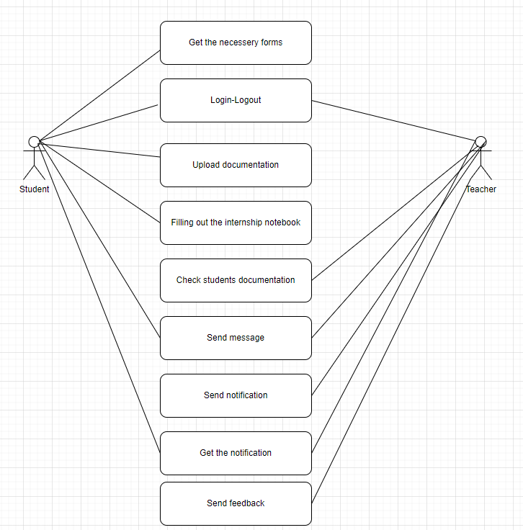

Fıgure 1

This is a case model for a teacher-student interaction system that includes the following features: Teachers and students can log in and log out of the system. Students can upload their documentation related to their internships. Teachers can access and check the students' documentation. The system provides forms that are necessary for the internship process. Teachers and students can send messages and notifications to each other. Students can receive feedback from teachers on their documentation and progress. Overall, this system aims to facilitate the internship process for both teachers and students by providing a centralized platform for documentation, communication, and feedback.

**3.4.3.1 - Object Model – Packages Mapped**

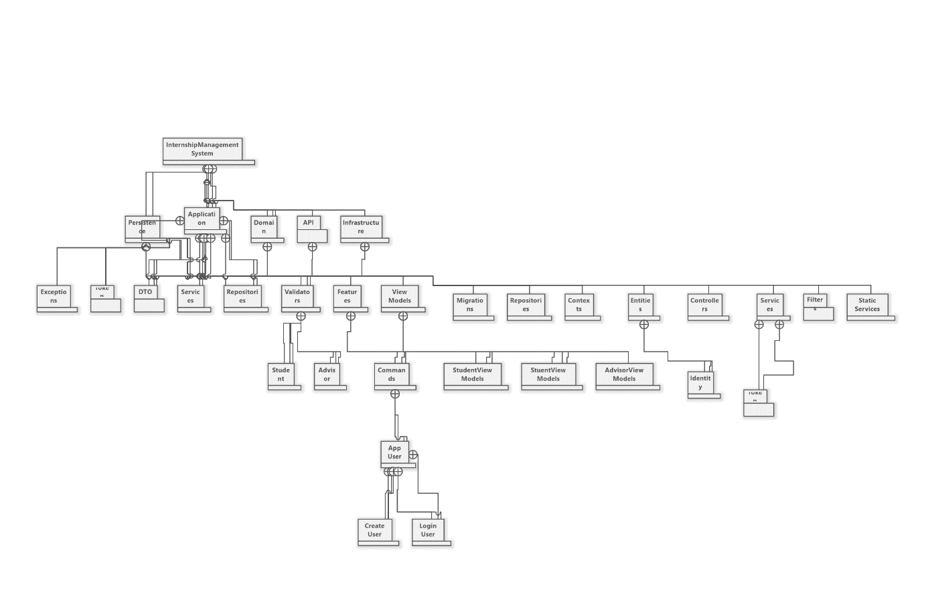

Figure 2

This Object Model - Packages Mapped model represents the software architecture of an Internship Management System. It includes the following components:

Application: This package contains the main application, along with the User and Student packages.

User package: This package includes the User entity, which represents a user of the system. It also includes the UserLogin controller, which handles user login and logout requests. Additionally, the UserMigrations class manages database migrations related to the User entity. Student package: This package includes the Student entity, which represents a student in the system. It also includes the StudentViewModels package, which contains view models for the student's views, and the StudentRepositories package, which manages data access and persistence for the student's data.

Domain: This package contains the Domain entity and the DomainContext class, which manages the domain's data access and persistence.

Identity: This package includes the Identity entities, which represent the authentication and authorization system in the application. Services: This package contains various services that are used throughout the system, such as the FilterService, StaticService, and TUREService.

Validators: This package includes the Validator entities, which are responsible for validating different parts of the system's data. Infrastructure: This package contains the infrastructure components, such as the database and API. DTO: This package includes the Data Transfer Objects (DTOs), which are used to transfer data between the different packages in the system.

**3.4.3.2 - Object Model**

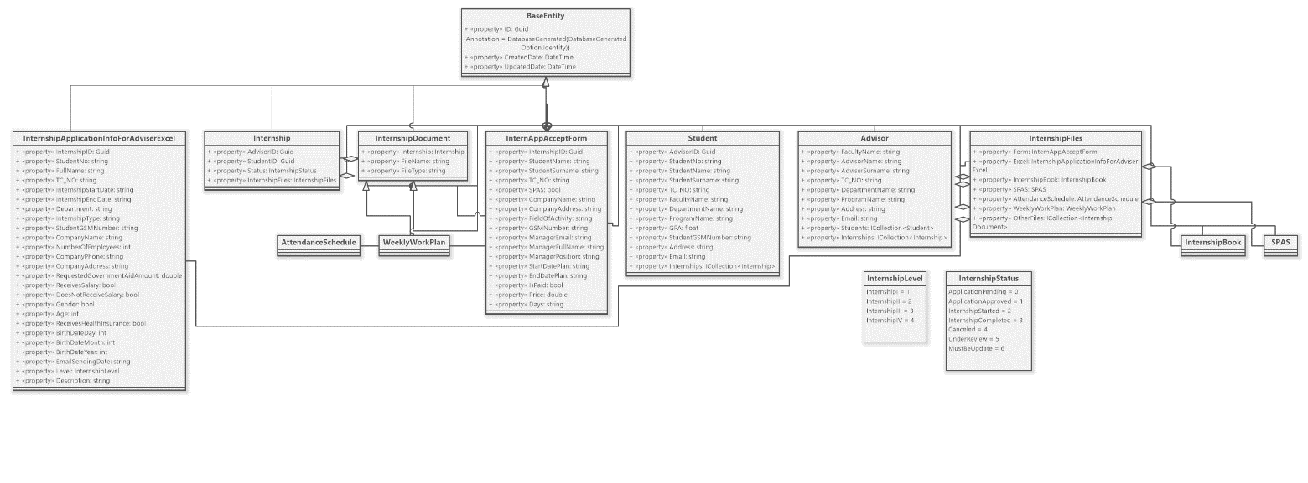

Figure 3

The InternshipApplicationInfoForAdviserExcel entity is a part of the Internship Management System and represents the information required for an internship application for an advisor in an Excel format. This entity is related to other entities such as Internship, AttendanceSchedule, InternshipDocument, WeeklyWorkPlan, and BaseEntity. These entities represent different aspects of the internship, such as attendance schedules, documents, and work plans. The BaseEntity entity provides common properties for all entities in the system, such as a unique identifier, creation date, and updated date.

**3.4.4 - Dynamic Model**

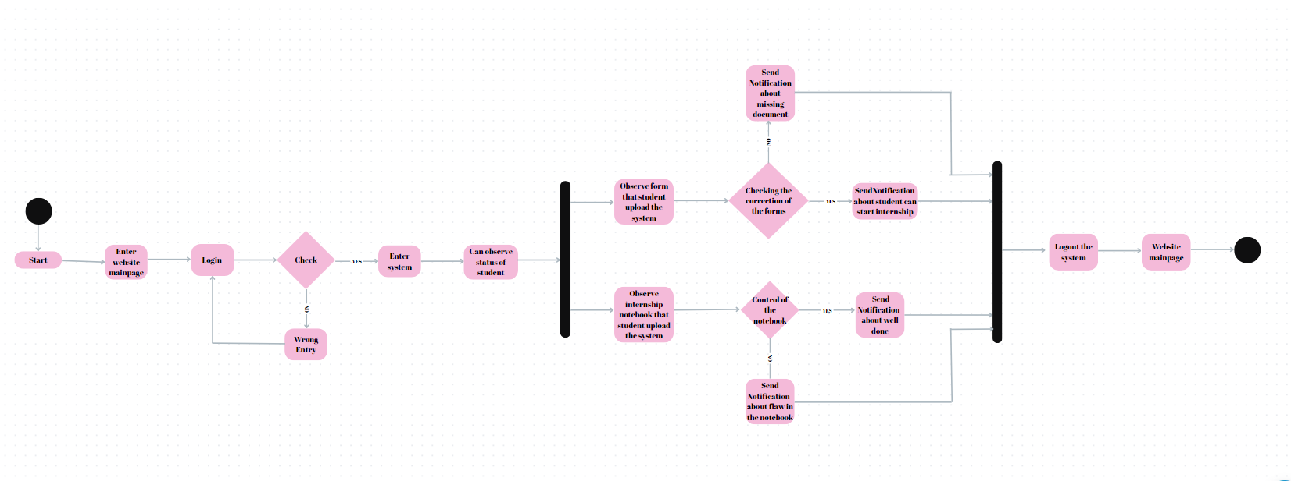

The dynamic model in the image shows the process of logging into a system on a website's mainpage, checking the status of a student, observing the forms and internship notebook they have uploaded, and sending notifications about missing documents or errors. If the login is successful, the user can enter the system and check the student's status. They can observe the forms that the student has uploaded and the internship notebook they have submitted. If any documents are missing, they can send a notification to the student. They can also check the correction of the forms and control the quality of the notebook. If there are any flaws, they can send a notification to the student. If the student has completed the notebook well, they can send a notification indicating that the student can start their internship. The user can then log out of the system. This process is then repeated when the user returns to the website's mainpage.

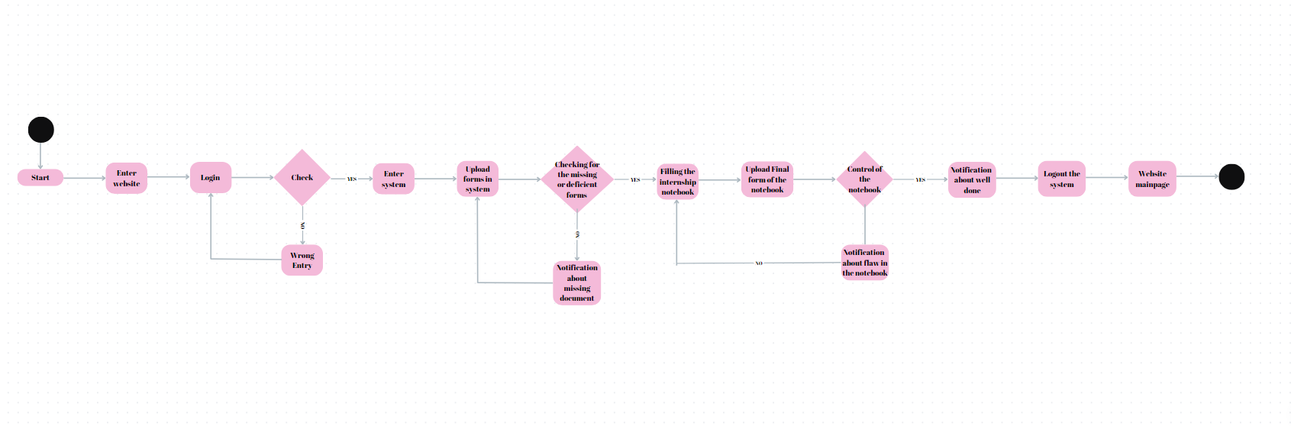

Figure 4

This text describes the steps taken on a website to login, upload forms, fill out an internship notebook, and check for any missing or deficient forms. The user is first prompted to enter the website and login. If the login is unsuccessful, an error message is displayed. Once logged in, the user can upload forms into the system. The system then checks for any missing or deficient forms and notifies the user if any are found. The user can then fill out the internship notebook, upload the final form, and have it checked for errors. If any flaws are found, the user is notified. If the notebook is well done, they will also receive a notification. Finally, the user can log out of the system. This process is then repeated when the user returns to the website's mainpage.

**3.4.5 -** **Database model — ER diagram**

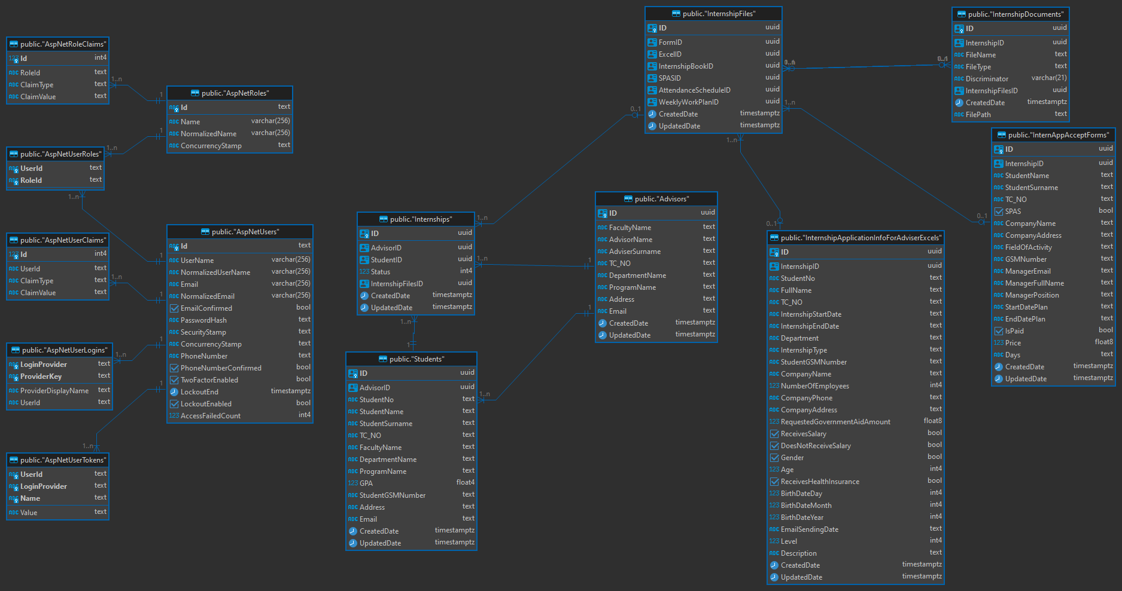

Figure 5

Student Advisor Internship and Entity Relationship Diagram depicting the relational models and their relationships at the entity level.

**3.4.6 - User Interface-Navigational Paths and Screen Mock-ups**

Home Page

Formun Üstü



Figure 6

We have emphasized user convenience on our homepage, and for this reason, we have adopted a simple design. Our homepage features an 'Announcements' section that welcomes visitors.

Internship directive



Figure 7

On our second page, you can find the internship guidelines section. We have added a link here, and by clicking on this link, users can access the PDF document containing the guidelines.

Formun Üstü

Internship Notebook



Figure 8

The internship notebook page provides a platform where relevant documents can be downloaded.

****Internship Forms

Figure 9

The internship forms page provides a platform where relevant documents can be downloaded.

Employment certificate



Figure 10

Contains information about the employment certificate.

Student and Advisor Login Screen

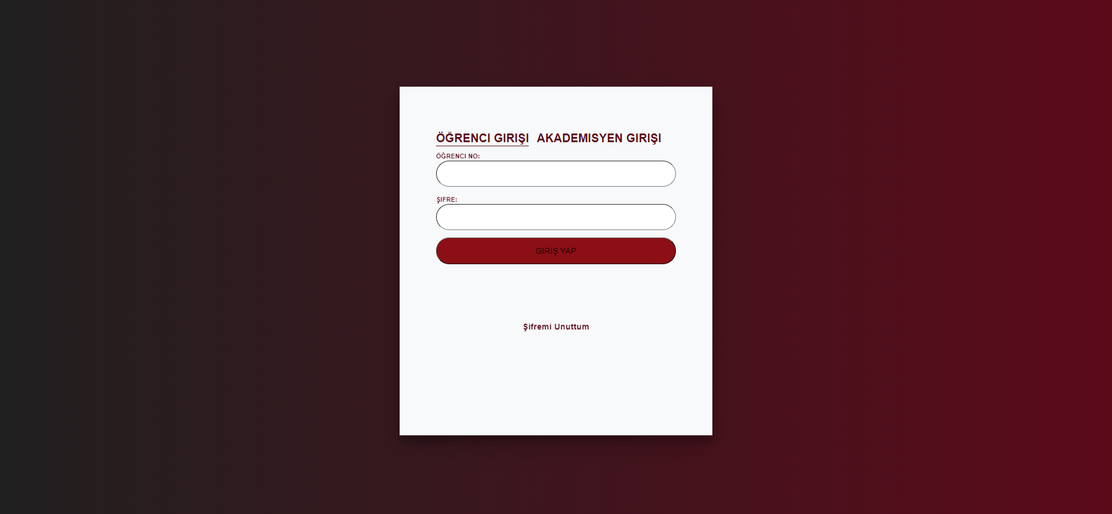

Figure 11

On the login screen, there are options for both student and advisor entries. For student login, the user needs to input their student ID and password, while for academic staff login, a username and password are required. We have incorporated an animation between the two login options for a dynamic user experience.Formun Üstü

Student Info

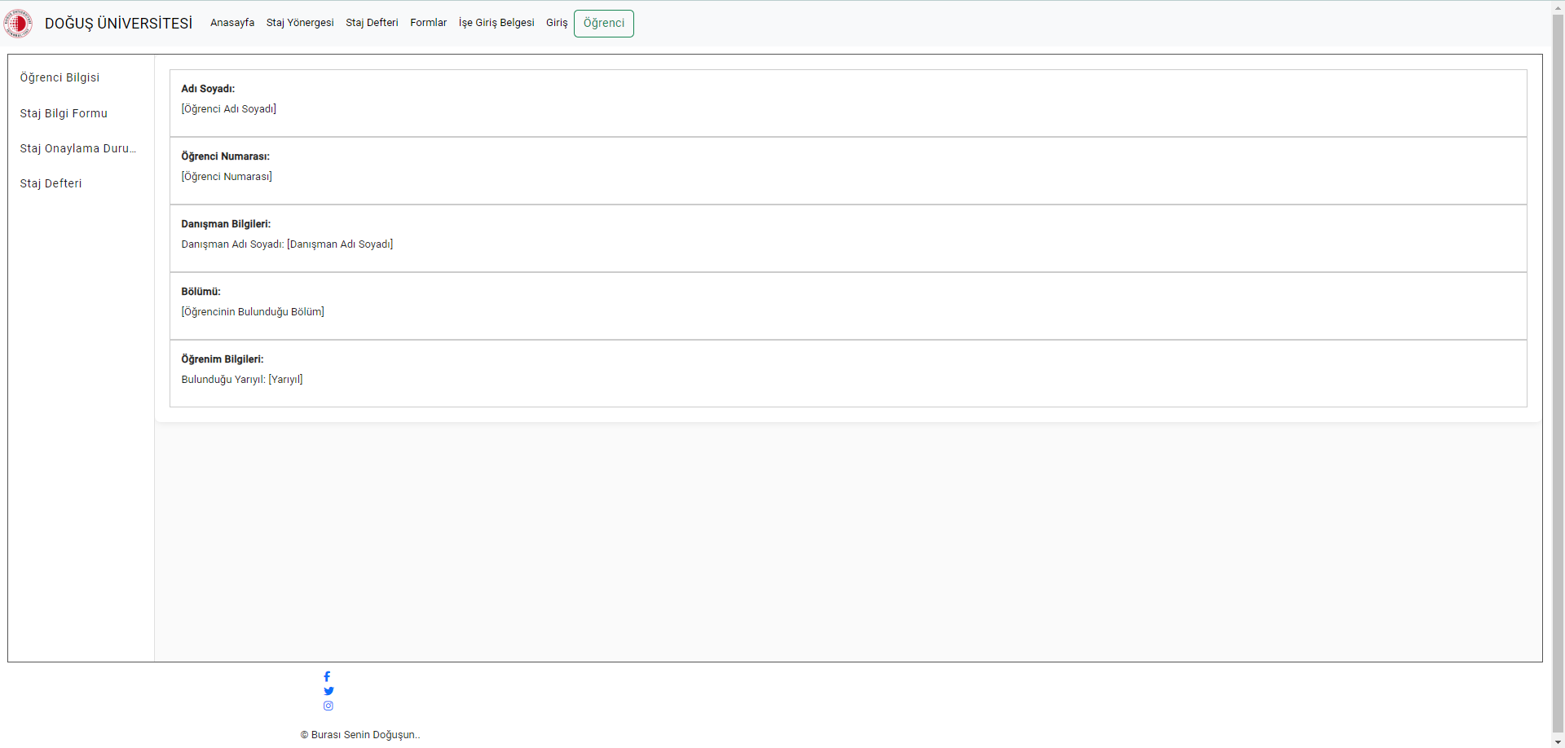

Figure 12

This section provides key details for students, including their personal information, advisor details, department, and current academic status. It offers a snapshot of essential information accessible upon login.

Internship Information Form (excel form)

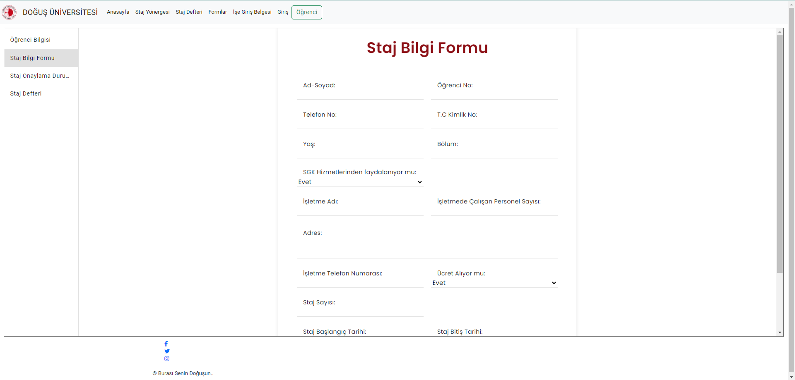

Figıre 13

The Internship Information Form, serves as a comprehensive tool for students to input crucial details about their internship. This section includes fields for both student and company information, as well as specific details like internship start and end dates. Students can efficiently submit and manage their internship particulars, enhancing the overall functionality of the system for streamlined internship data collection and processing.

Intrership Approval

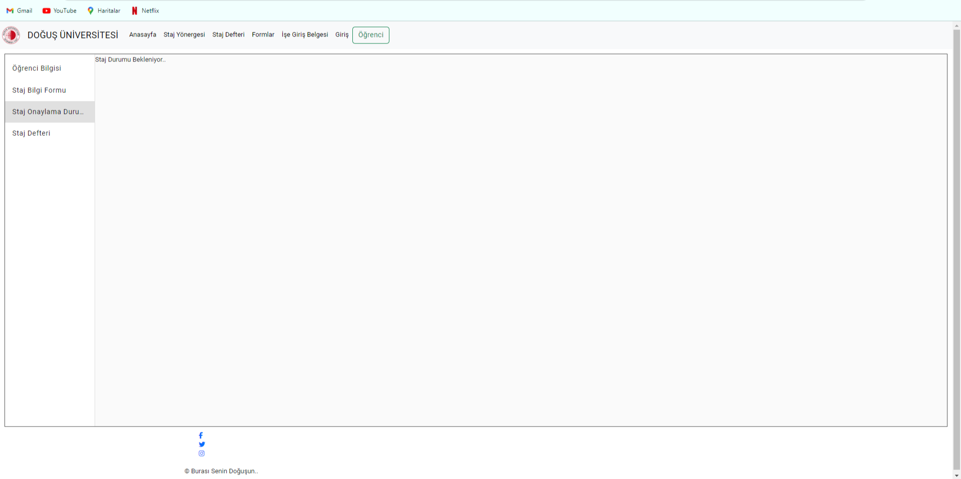

Figure 14

The Internship Approval Status provides students with real-time updates on the approval status of their internship, offering a clear indication of whether the internship has been approved or is still pending confirmation. This section ensures transparent communication and effective monitoring of the internship approval.

Internship Notebook

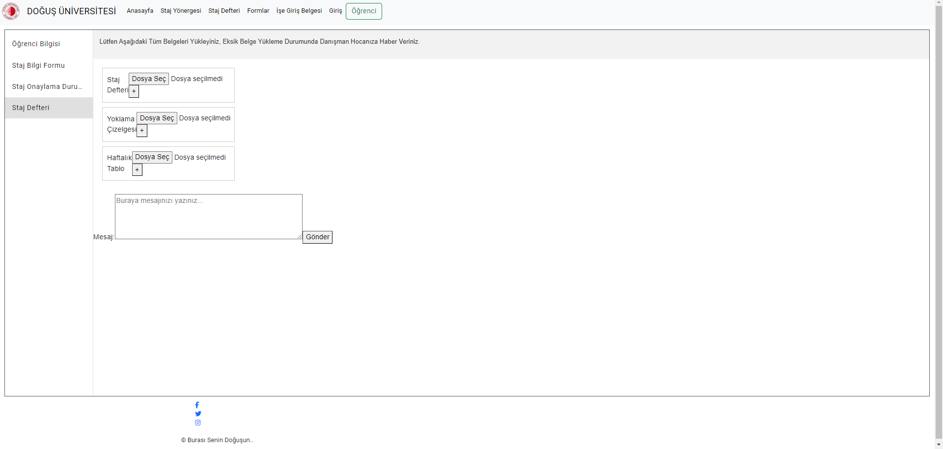

Figure 15

This page enables students to upload essential documents like the Internship Journal, Attendance Schedule, and Weekly Table. These documents are accessible to the academic advisor, facilitating seamless monitoring of the student's progress. Additionally, a messaging section allows students to communicate with their academic advisor, providing a dedicated space for inquiries or updates related to the internship. This integrated approach enhances collaboration and communication between students and academic advisors throughout the internship period.

**4 GLOSSARY**

Intern: A student undergoing an internship program.

Advisor: A faculty member responsible for guiding and evaluating the intern.

Document Upload Functionality: The feature allowing users to upload required internship documents.

Feedback Process: The mechanism for providing and receiving feedback between interns and advisors.

**PROJECT BUDGET AND TIME PLAN**

**5. INTRODUCTION**

A project plan is one of the crucial components for the success of a project. It is used to document and communicate expectations, control the schedule and delivery, and assess and manage risks. Generally, it serves as a roadmap for everyone involved in the project.

**5.1 Gantt Chart**

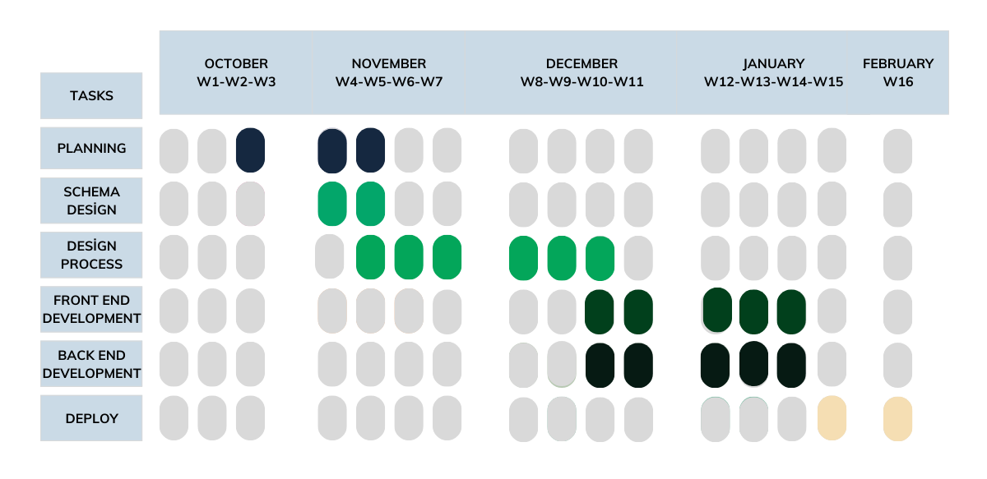

Figure 16

**5.2 Project Budget**

**Project budget table**

|  |  |  |  |  |
| --- | --- | --- | --- | --- |
|  | **Estimated** | | | **Actual** |
| **Expenses** | **Period**  **(One time or Recurrent)** | **Cost per Period** | **Total Cost** | **Total Cost** |
| License for Visual Studio | 1 Time | free | 0 | 0 |
| Travel | 2 Times | 300 TL | 600 TL | 400 TL |
| Accommodition | - | - | - | - |
| License for Balsamiq | 1 Time | free | 0 | 0 |
| Gençay Yıldız Educational Cost | 5 Times | 120 TL | 600TL | 500TL |
| TOTAL BUDGET | | | 1.200 TL | 900TL |

*Table 1*

**5.3 Project Phase Distribution**

|  |  |  |
| --- | --- | --- |
| **Planning and Analysis** | **Desing** | **Application** |
| %40 | %30 | %30 |

*Table 2*

**5.4 Other Tables - Meeting Information**

|  |  |
| --- | --- |
| **November 2023** | **December 2023** |
| 10.11.2023-Friday | 15.12.2023-Friday |
| 17.11.2023-Friday | 22.12.2023-Friday |
| 24.11.2023-Friday |  |

|  |
| --- |
| **January 2023** |
| 10.11.2023-Friday |
| 17.11.2023-Friday |

*Table 3*

**PROJECT SPECIFIC CONTENT**

**6. INTRODUCTION**

In the dynamic landscape of contemporary education, the Internship Tracking System project emerges as a transformative solution to modernize and optimize internship processes. Recognizing the crucial role of internships in shaping students' professional journeys, the system integrates digitalization and technological innovations to bring efficiency and effectiveness to traditional internship management. This web-based platform offers a comprehensive solution for students seeking internships and teachers overseeing these crucial experiences. The project envisions a seamless journey for internship candidates, providing an intuitive interface for the entire process, from adhering to university criteria during application to the official commencement of internship programs. Throughout the internship, students are equipped to maintain and submit daily internship notebooks, streamlining administrative tasks for both students and departmental staff. The platform's design accelerates, simplifies, and centralizes the management and monitoring of internships, marking a significant departure from conventional practices. In aligning with broader educational objectives, the Internship Tracking System seeks to achieve a harmonious blend of technology and pedagogy. The overarching goal is to empower users within the system, ensuring they can effortlessly navigate tasks, complete operational practices, and engage in transparent communication. The success of the project is contingent on its ability to establish a user-friendly environment that enhances the internship experience, offering tangible benefits to students and facilitating effective communication between interns and advisors.

**6.1. Accesibilty**

The targeted users in this project are the students of the Computer Engineering Department at Doğuş University.

Formun Üstü

**6.2.** **User Manual**

1. When students access the website, they encounter a page related to internships containing the necessary information.
2. Students log in with their school ID and passwords, and upon login, they are prompted to fill in student information, confirm the form submission, and upload internship diaries.
3. Students must complete the information form first to obtain internship approval; without completing the form, approval is not possible.
4. After receiving confirmation, students are required to continue uploading their internship notebook.

**6.3.**  **Test Plan**

There is currently no test plan in our application.

**6.4 Maintenance Plan**

Backed by redundant servers and disk backups, maintenance and upgrade procedures can be executed as needed. Planned changes can be implemented on passive servers while the redundancy systems are in an active or passive state

**CONCLUSION AND DISCUSSION**

Our project holds a pivotal role in streamlining the internship process, aiming to create a visually appealing platform that ensures both students and advisors can navigate effortlessly without experiencing visual fatigue. The website has been meticulously designed to provide a user-friendly interface, recognizing the importance of a seamless experience for students who will undergo three internships. While the deployment phase is yet to be completed, we remain optimistic about refining the project further to enhance its usability for both students and advisors. The objective is to create a platform that not only meets but exceeds the expectations of its users, providing a robust and efficient system for managing the internship process. Drawing from our extensive experience in project management within our team, we are confident that these skills will seamlessly transition into our professional careers. The lessons learned from our journey so far have equipped us with the ability to efficiently collaborate and overcome challenges, an invaluable asset for the workplace. However, it's important to acknowledge that our current system falls short of our envisioned greatness. We recognize that there were some suboptimal decisions made during the development and design phases, limiting our ability to implement certain features. Despite these challenges, we are committed to continuous improvement and are dedicated to working tirelessly until we achieve a successful and impactful deployment of the project. The resilience of our team and the lessons learned from past mistakes will undoubtedly contribute to the eventual success of our endeavor.

**REFERENCES**

1. Applying UML and Patterns, 3rd Ed., Craig Larman, Prentice-Hall, 2007

2. UML Distilled, 3rd Edition, Martin Fowler, Addison-Wesley, 2003

3. Head First Object Oriented Analysis and Design, Brett D. McLaughlin, Gary Pollice, Dave West, O'Reilly Media, 2006, ISBN: 059600867

4. Head First Design Patterns, by Eric Freeman, Elisabeth Robson and Bert Bates 2004, O'Reilly Media, ISBN: 0596007124

5. Software Engineering: Theory and Practice, 4th Ed., Pfleeger & Atlee, Prentice Hall, 2009 6. Thinking in C++, Bruce Eckel

7. <https://github.com/gncyyldz>

8. <https://www.gencayyildiz.com/blog/\>

**APPENDIX**

[**Staj Yönergesi: Doğuş Üniversitesi Staj Uygulamaları Usul ve Esasları**](https://www.dogus.edu.tr/docs/default-source/yonergeler/yonergelerimiz/staj-uygulamalari-usul-ve-esaslari.pdf?sfvrsn=5552b7a4_4)

https://www.dogus.edu.tr/docs/default-source/yonergeler/yonergelerimiz/staj-uygulamalari-usul-ve-esaslari.pdf?sfvrsn=5552b7a4_4

[**Dış Kapak:**](https://muhendislik.dogus.edu.tr/docs/librariesprovider5/staj/staj-defteri/staj-defteri-dis-kapak-turkce.docx?sfvrsn=c6f1c438_12)

https://muhendislik.dogus.edu.tr/docs/librariesprovider5/staj/staj-defteri/staj-defteri-dis-kapak-turkce.docx?sfvrsn=c6f1c438_12

[**İç Sayfalar:**](https://muhendislik.dogus.edu.tr/docs/librariesprovider5/staj/staj-defteri/staj-defteri-ic-sayfa-turkce.docx?sfvrsn=ea060e3e_12)

https://muhendislik.dogus.edu.tr/docs/librariesprovider5/staj/staj-defteri/staj-defteri-ic-sayfa-turkce.docx?sfvrsn=ea060e3e_12

[**Yoklama Çizelgesi:**](https://muhendislik.dogus.edu.tr/docs/librariesprovider5/staj/staj-defteri/staj-defteri-yoklama-cizelgesi-turkce.docx?sfvrsn=5fd3bb17_10)

https://muhendislik.dogus.edu.tr/docs/librariesprovider5/staj/staj-defteri/staj-defteri-yoklama-cizelgesi-turkce.docx?sfvrsn=5fd3bb17_10

[**Haftalık Tablo:**](https://muhendislik.dogus.edu.tr/docs/librariesprovider5/staj/staj-defteri/staj-defteri-haftalik-tablo-turkce.docx?sfvrsn=932b7443_8)

https://muhendislik.dogus.edu.tr/docs/librariesprovider5/staj/staj-defteri/staj-defteri-haftalik-tablo-turkce.docx?sfvrsn=932b7443_8

[**Staj Defteri Günlük-Haftalık Genişletilmiş Rapor:**](https://muhendislik.dogus.edu.tr/docs/librariesprovider5/staj/staj-defteri/staj-defteri-gunluk-haftalik-genisletilmis-rapor-turkce97a11801437d48a5b91eca788eea7592.docx?sfvrsn=e5962ca9_8)

https://muhendislik.dogus.edu.tr/docs/librariesprovider5/staj/staj-defteri/staj-defteri-gunluk-haftalik-genisletilmis-rapor-turkce97a11801437d48a5b91eca788eea7592.docx?sfvrsn=e5962ca9_8

[**Mühendislik Fakültesi Staj Uygulamaları Usul ve Esasları**:](https://muhendislik.dogus.edu.tr/docs/librariesprovider5/staj/formlar/m%C3%BChendislik-fak%C3%BCltesi-staj-uygulamalari-usul-ve-esaslari.docx?sfvrsn=8bd90350_)

https://muhendislik.dogus.edu.tr/docs/librariesprovider5/staj/formlar/m%C3%BChendislik-fak%C3%BCltesi-staj-uygulamalari-usul-ve-esaslari.docx?sfvrsn=8bd90350_6

[**İş Yeri Tarafından İletilecek Staj Ücretlerinin İşsizlik Fonu Katkısı Bilgisi:**](https://muhendislik.dogus.edu.tr/docs/librariesprovider5/staj/formlar/i%C5%9F-yeri-taraf%C4%B1nda-iletilecek_staj-%C3%BCcretlerine-i%C5%9Fsizlik-fonu-katkisi-bilg.docx?sfvrsn=eb4795b4_8)

https://muhendislik.dogus.edu.tr/docs/librariesprovider5/staj/formlar/i%C5%9F-yeri-taraf%C4%B1nda-iletilecek_staj-%C3%BCcretlerine-i%C5%9Fsizlik-fonu-katkisi-bilg.docx?sfvrsn=eb4795b4_8

[**Stajyer Öğrenci Değerlendire Formu:**](Stajyer%20Öğrenci%20Değerlendire%20Formu:)

https://muhendislik.dogus.edu.tr/docs/librariesprovider5/staj/formlar/stajyer-ogrenci-degerlendirme-formu.docx?sfvrsn=6dc834dc_8

[**Staj Başvuru ve Kabul Formu**:](https://muhendislik.dogus.edu.tr/docs/librariesprovider5/staj/formlar/staj-basvuru-ve-kabul-formu.docx?sfvrsn=29a27fee_10)

https://muhendislik.dogus.edu.tr/docs/librariesprovider5/staj/formlar/staj-basvuru-ve-kabul-formu.docx?sfvrsn=29a27fee_10

[**Staj Yeri Değişikliği Başvurusu Formu:**](https://muhendislik.dogus.edu.tr/docs/librariesprovider5/staj/formlar/staj-yeri-degisikligi-basvuru-formu.docx?sfvrsn=d1e02ced_8)

https://muhendislik.dogus.edu.tr/docs/librariesprovider5/staj/formlar/staj-yeri-degisikligi-basvuru-formu.docx?sfvrsn=d1e02ced_8

**BIOGRAPHY**

Muhammedtalha Sakaoğlu

My name is Muhammedtalha Sakaoğlu. I completed my primary education in multiple cities and schools. I was born in 1997, and my interests are currently focused on backend architectures; however, I don't find myself creative on the interface side. I have lost faith in the idea that education can be obtained solely from school. Perhaps I can provide a summary: Education can be made more effective through a combination of research passion and being rewarded for success. I believe that the titles of those who accomplish good and different tasks should be elevated and rewarded. This can allow individuals to keep their minds open in a system where they can acknowledge that making mistakes is part of being human.

Taner İleri

I was born on October 25, 2000. I spent my entire education life in Tekirdağ until high school. I studied at Ramazan Yaman Science High School in Kırklareli Lüleburdaz until the 11th grade. In the 12th grade, I transferred to Çorlu Nazmi Arıkan Private Science Schools. I am currently continuing my education at Doğuş University.

Ayça Sena Akın

Born on May 26, 2000, in the Pendik district of Istanbul, commenced her educational journey. She spent the initial years of his high school education at Behiye Dr. Nevhiz Işıl Anatolian High School and later transferred to Atalar Fen Bilimleri High School for his final years. In 2019, earned admission to Doğuş University, where he is currently progressing as a fourth-year student. With aspirations to specialize in frontend development in his future professional endeavors, she actively engages in projects to fulfill this career goal.

Koray Kocaelli

I was born in Edirne on March 27 2000, and I went to school in Kırklareli Babaeski all the way up to high school. At Lüleburgaz Anatolian High School in Kırklareli Lüleburgaz, I continued my study. I'm currently attending Doğuş University to further my academic career. I am a final year student in computer engineering. I am deeply passionate about both backend and frontend development, actively honing my skills in both areas. Currently, I am gaining hands-on experience as a Java Software Developer Intern at Kafein Technology Solutions, where I am applying and enhancing my knowledge in both backend and frontend technologies.

Bahadır Öztürk

I was born in Berlin on January 13, 2000. I completed my high school education at Istanbul Anatolian High School. I am an active 4th year computer engineering student at Doğuş University. I am interested in web design and I am doing small projects in this field.